2016 Florida
Safe Routes to School
Non-Infrastructure
Information Form

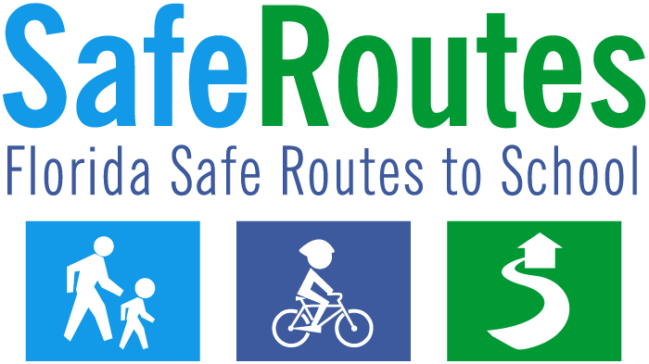

Section 1 – School & Applicant Information
Proposed Activity or Program
Name of Proposed Activity or Program:
Brief Description of Proposed Activity or Program:
School Information
County or Counties:
City or Cities:
Type of school(s) (check all that apply): Public Private
Elementary Middle High Other types of schools*
* Explain Other schools below
Number of schools involved
1-3 schools involved. Name(s) of school(s)
#1:
#2:
#3:
Multiple schools. Explain below how many schools will be involved, and their involvement.
Applicant Information

School Board Private School Governmental Agency Other
Name of Agency/Organization:
Contact Person: |  |  |  | Title:
Daytime Phone: |  |  | E-mail:
Mailing Address:
City: |  | State: Florida |  |  | Zip:
Signature: | Typed Name: |  |  |  |  | Date:
Signature of School Board or school representative required when different from applicant:
Signature: | Typed Name: |  |  |  |  | Date:

Section 2 – General Program Information
- Data Collection: Please review the data collection forms found at this link: http://www.saferoutesinfo.org/resources/index.cfm. Baseline data collection is required at the beginning of your program and follow-up data collection is required at its completion.
Do you agree to provide this data following the FDOT District’s schedule? Yes No
Please describe how you plan to collect this data.
2. Target population information: Describe below the population targeted, including:
- the demographics of your target population
- the number of children in the school or schools
- how many children you plan to target with your program
- how many children currently walk or cycle to school
- how many more children would be able to walk or cycle to school if your program is successful
- if your program (or part of it) is directed toward adults, how many adults you plan to involve
3. Problem identification: Describe below what problem you are trying to address. Consider the current walking and cycling conditions in your project area, any problems or obstacles children encounter when they walk or cycle to school, educational needs, etc.

4. Proposed solution: Describe below your proposed solution is and how it will help solve the problems you have identified. Please write this in the form of a Scope of Services narrative. Include:
- what the program consists of
- what students you are targeting (the whole school or targeted groups)
- who your partners are and how they will help you with this program
- if there is personnel involved, explain who the personnel are, what they will be doing, and how compensation was figured
- whether the project addresses problems within two miles of the school

Section 3 A– Background Information: Planning
SRTS projects are most successful in the context of comprehensive planning
Describe below your past school planning efforts:
- Has your school used the Florida Safe Ways to School Tool Kit, or a similar planning process to
develop its proposals? (see http://www.dcp.ufl.edu/centers/trafficSafetyEd/html_safe-ways.html)
- Who participated in the school planning efforts?
- Describe the planning process for accessibility to your school
- Does your school have approved walking maps? If so, how were these developed?
- Have you discussed school traffic, safety, or access problems with the Community Traffic Safety
Team? If so, what were the results?
Describe below your future school planning efforts:
- What method do you plan to use?
- Who do you plan to involve?
- What is your timeline?

Section 3B– Background Information: The 5 E’s
Safe Routes to School is designed to be a comprehensive program, encompassing the Five E’s listed
below. Describe what efforts your school has made to address the identified problem through each E
so far, and what is planned in the future. Each box must be filled in. For more explanation of the Five E’s, see the Florida’s Safe Routes to School Guidelines or http://www.saferoutesinfo.org/guide/

Past | Future
Engineering: | Engineering:
If your school has taught or plans to teach the Florida Traffic and Bicycle Safety Education Program
(FTBSEP) or a similar program, provide details in the “Past Education” box below.
For more information on this program, see http://www.dcp.ufl.edu/centers/trafficSafetyEd/

Education: | Education:
Encouragement: | Encouragement:
Enforcement: | Enforcement:
Evaluation: | Evaluation:

Section 4– Budget Detail & Narrative
Below each item, explain how the item will support the program, and other appropriate details.
Budget Item | Requested Funds
Personnel Services* (List titles and totals in first boxes below)
In Narrative, include numbers of hours, hourly rates, who this person is, and whether it’s a new position or new hours and duties added to an existing position.
Narrative:
Narrative:
Narrative:
Expenses:
Materials and Supplies:
Educational items:

Promotional Items:
Other Expenses:
Operating Capital Outlay:
Equipment:
Total Request:

Section 4B – Budget Narrative
Explain any voluntary local matches for your program:

Explain in more detail below:
- What each requested budget item listed is
- How each will be used in your activity
Personnel Services:
1. Item detail:

2. Activity:
Expenses: Materials and Supplies
1. Item detail:

2. Activity:
Expenses: Educational items
1. Item detail:

2. Activity:
Expenses: Promotional Items
1. Item detail:

2. Activity:
Expenses: Other Expenses
1. Item detail:

2. Activity:
Operating Capital Outlay:
1. Item detail:

2. Activity:

